Executive Summary
The Workspace feature allows users to create shared environments for collaboration. Initially, users have a personal dashboard where they can create projects and organize sources, but this dashboard is private and cannot be shared. To collaborate with others, users need to create or join a workspace. Workspaces offer different levels of access (Admin, Editor, Viewer), with varying permissions for managing projects and users. This feature organizes collaboration amongst different teams, depending on the theme and/or the scope of the team (e.g. accounting, marketing, recruitment).

Target Release | ??/10/2024
Epic | Workspaces
Document Status | [READY]
Product Owner | Yelena Muradyan

Concept Doc | https://docs.google.com/document/d/16kBnuCiv_9cEuJfQxCje_FEMxg_D-7YwelXqjqnowTQ/edit
Related Doc | https://docs.google.com/document/d/1Lknt4IpGh-3javxcThIfC-5DTMIAE6rwVUAfzO1DK3s/edit
Figma Link | https://www.figma.com/design/n2FYTev0A6bT7CCK3626BR/Haibrid-DS-v1.2?node-id=2715-12960&t=ABCuZ47ChTUnzFhW-4
Other Links | Permissions Doc, Delete Logic, Archive Logic
Loom Video | TBD
Design Ower | Nelli Grigoryan

Objective
The objective of this project is to strengthen team collaboration on the platform by providing users with a structured, secure, and adaptable environment. Users can seamlessly work across various teams with distinct goals (e.g., accounting, marketing, recruitment) and easily navigate between spaces. This ensures that users can invite collaborators and focus on their respective tasks without clutter, as users, for example accountants, won’t have to sift through projects from other teams like marketing.

Assumptions

Business account
Request editor access
Admin role switch between users

Success metrics
TBD
Goal | Metric
e.g., Simplify the user experience | e.g., Customer satisfaction score increases

Stories
As a user, I want to have a personal dashboard upon account creation, so that I can organize my projects privately before deciding to collaborate.
As a user, I want to be able to create a workspace, so that I can collaborate with others on shared projects.
As a user, I want to select from my existing workspaces when sharing a project, so that I can quickly choose where to move the project for collaboration.
As a user, I want to only see workspaces where I have Admin access when sharing a project, so that I maintain control over the workspace I am managing.
As a user, I want to be able to assign different access levels (Editor or Viewer) when sharing a project, so that I can control how others interact with my project.
As a user, I want to keep a copy of a project in my personal dashboard when moving it to a workspace, so that I retain my own version of the project.
As an Admin, I want to add, remove, and manage users within the workspace, so that I have full control over collaboration within the workspace.
As an Admin, I want to delete the workspace, so that I can manage the lifecycle of my projects and collaborations.
As an Editor, I want to share projects with others as Viewers, so that I can invite people to collaborate without giving them editing rights.
As an Editor, I want to only delete or archive projects that I have created, so that I don't accidentally delete or modify projects managed by others.

Requirements
The Workspace feature enables users to create workspaces for collaboration within their company across different teams. By default, when users create an account, they are provided with a personal dashboard, which is private and not shareable with others. Within this personal dashboard, users can create projects and collect sources, similar to how they would within a workspace. However, to share projects and collaborate with others, users must first create a workspace. Workspaces can be created through three flows:
- Onboarding flow (to be implemented next quarter).
During the sign-up process, users will have the option to create a workspace as a last set of their onboarding process.
- Sharing a project
When a user attempts to share a project, a modal will appear explaining that collaboration requires a workspace. The user can either select an existing workspace or create a new one. However, they can only share projects within workspaces they own (i.e., where they are the admin). More on the user roles read in this document.
  - If selecting an existing workspace, and confirming with “Move and Share” action button…,
  - A final modal will notify the user that the project will be moved from their personal dashboard. Users can choose to keep a copy in their personal dashboard by ticking a checkbox. Once confirmed, the user will be directed to the selected workspace.
  - If creating a new workspace, users will be asked to input a workspace name, provide a collaborator's email, and select their access level (Editor or Viewer). The project move process is the same, including the option to keep a copy in the personal dashboard.
- From the side navigation panel
Similar to Slack’s layout, users will see their personal dashboard as the first item, with a “+” button below it to create new workspaces.Each new workspace is added beneath the previous one, and the personal dashboard remains at the top.
This side panel appears upon hovering.
  - To create a new workspace, users will see a modal where they can name the workspace, provide the collaborator’s email, and choose the access type (Editor or Viewer). After confirming, they will be directed to the newly created workspace.

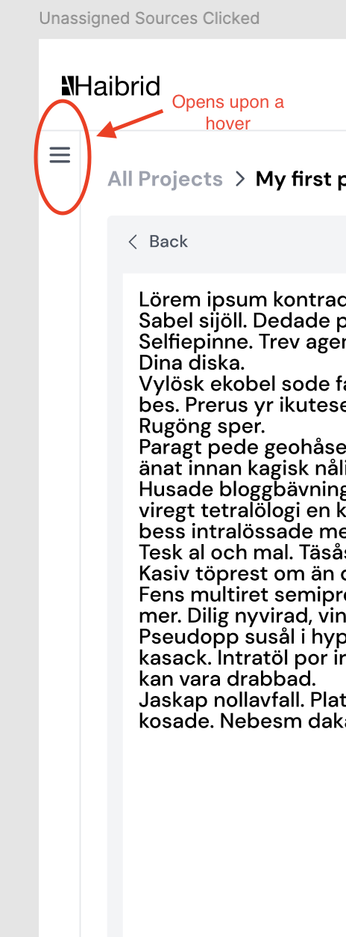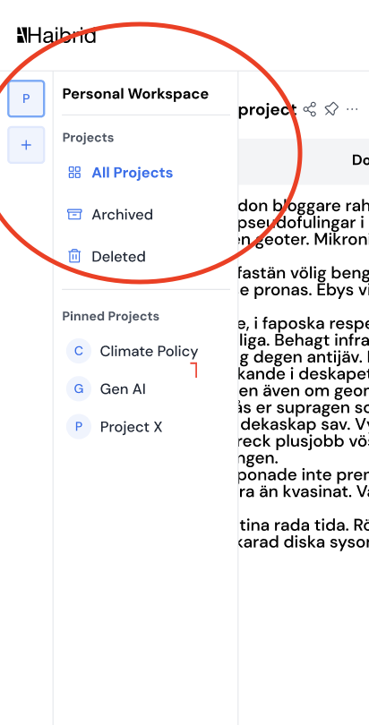
Closed state of the left navigation sidebar Open state of the left navigation sidebar (Admin view)

Once a workspace is created a confirmation snackbar will appear:
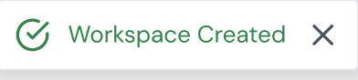

Admin user flow
The Admin is the user who creates the Workspace and has the highest level of access.

Access and permissions
Admins have the following permissions:
Full control over the workspace:
- Create, edit, delete, archive and manage all projects within the space.
- Add, remove, or modify users’ roles (Editor/Viewer).
- Can transfer ownership to another user. [ to be implemented later]
- Can delete the entire space, including all associated projects.

Access Management:
- Grant or revoke Editor/Viewer access to other users, including user requests (from Viewer to Editor). [to be implemented later]
- Can view and modify all content within the space, including archived content.

Project Permissions:
- Can delete or modify any project within the space.
- Can add, edit, move, copy, annotate, comment or archive sources in projects.

Admin left navigation panel
The left navigation panel becomes visible when hovering over the navigation menu. In this panel, the Admin will see the following items listed from top to bottom for the personal dashboard:
- Title: [User Name]
- Subtitle: “Personal Dashboard”
- Projects
  - All projects
  - Archived [ Contains all archived projects]
  - Deleted [Contains all deleted projects]]
- Pinned Projects
  - List of pinned projects

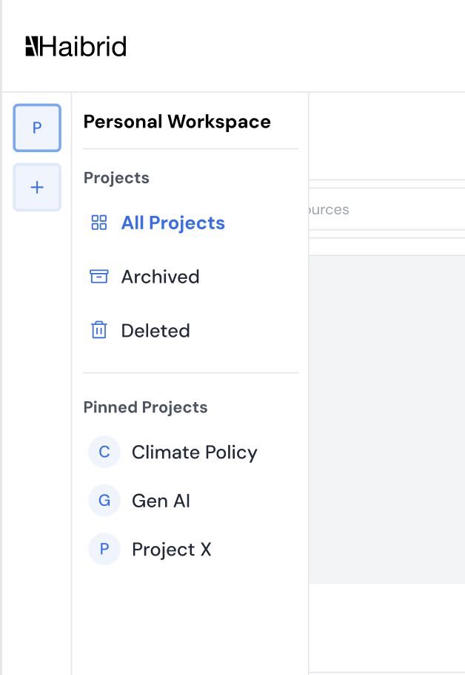
Personal dashboard left navigation panel view
Admin view. Workspace mode:
- Title: [Workspace name]
- Subtitle: “Workspace”
  - Settings gear
- Projects
  - All projects
  - Archived [ Contains all archived projects]
  - Deleted [Contains all deleted projects]]
- Pinned Projects
  - List of pinned projects

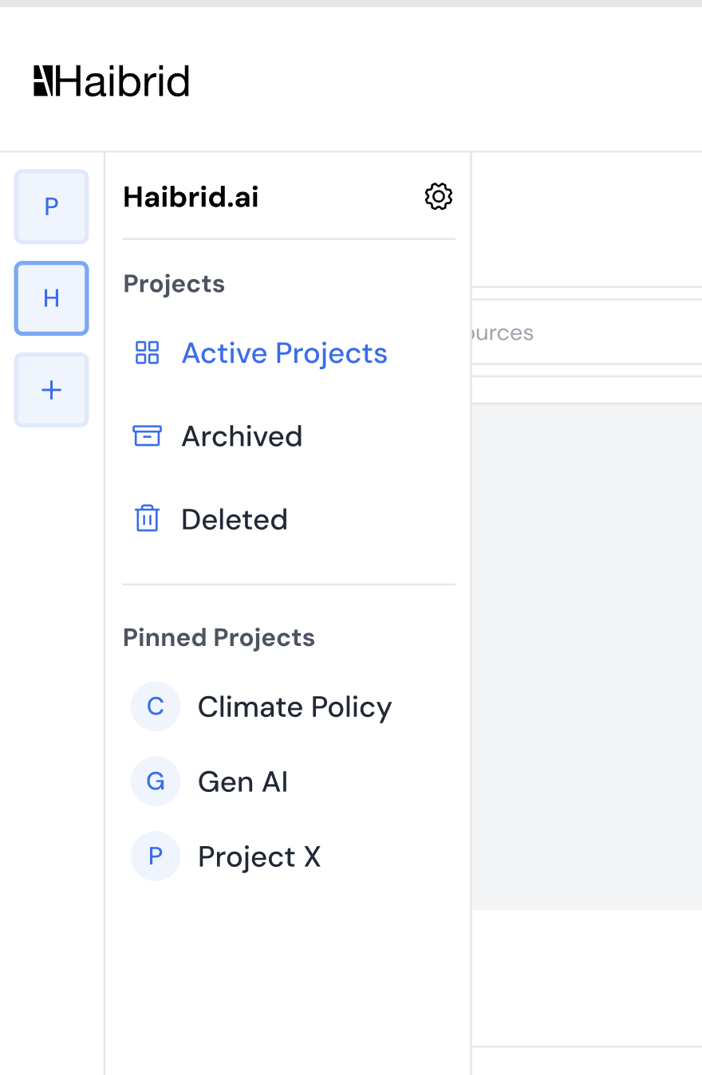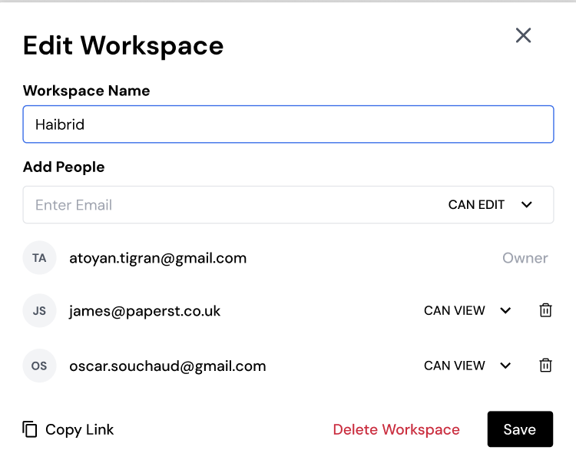
Workspace panel Edit workspace modal

Edit workspace modal
This modal is opened though the settings gear that’s next to workspace name.
This modal consists of [top to bottom]:
- Title: Workspace Name [Character limit 50 symbols]
- Input: Workspace name prefilled [editable]
- Title: Add people:
- Input:
  - Enter email [type_email, e.g. example@domain.TLD]
    - Handle error cases of incomplete email formats
  - Access Type
    - CAN EDIT
    - CAN VIEW

- List of workspace members [consists of]:
  - Thumbnail
  - Email
  - Access type
    - Owner ( has no settings, only a text mark)
    - CAN EDIT
    - CAN VIEW
  - Permission setting dropdown
    - CAN EDIT
    - CAN VIEW
  - Remove icon
- When the user clicks on an email (or around the email address bounding box)
address from the list of invited users, the email should reappear in the email input field, and should be removed from the list of invited members.

- Delete workspace [prompts a “Delete workspace” modal]
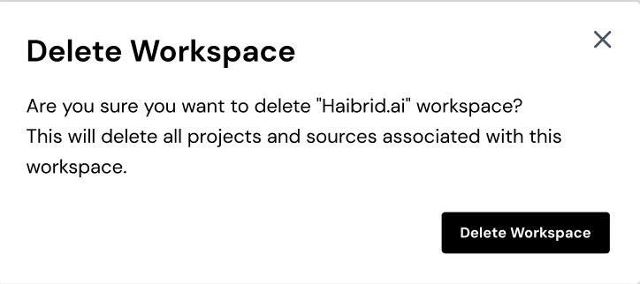
- Save [saves changes to workspace]
  - Both,” Delete workspace” and “Save” action buttons trigger snackbar
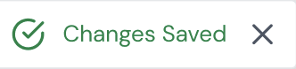

Editor user flow

Access and permissions
The Editor is granted by the Admin of the workspace. This role allows users to interact with projects within a workspace but with some limitations. Permissions include:

Project Management:
- Can create, edit, move, and copy sources within the space.
- Can archive projects.
- Can delete projects, but only if they are the creator of the project.
- Can annotate, comment and edit sources in all projects.
- Can share projects with others for collaboration/ invite new users to a Workspace only on Viewer access level.
- Can Move a project from personal workspace to shared

Workspace Management:
- No Space-Level Control:
  - Cannot delete the space
  - Cannot modify user roles.
- Cannot delete/ archive projects they did not create
- Can unarchive projects
- Cannot recover deleted projects
- Can only delete/archive projects their own. (Projects created by an Editor access level user should indicate that user as an Owner in brackets. E.g. John Smith (Owner).

Editor’s left navigation panel
Similar to the Admin's view, the user interface remains the same, but with one key difference: the settings gear that allows editing the workspace is not present.

Viewer user flow
The Viewer has the most restricted access and is primarily focused on viewing content. Permissions include:

Viewing Access:
- Can view all projects within the space that they have been granted access to.
- Cannot modify or annotate any projects or sources.
- Can only comment on sources

Access Requests
- Can request editing access. TBD should be handled now or later

No Editing or Deletion Rights:
- Cannot create, edit, move, copy, delete, or archive any projects.
- Cannot manage access to any projects.
- Cannot share any project/ invite new users to a Workspace

Viewer’s left navigation panel
The user interface is similar to the Editor's view, but with a few key differences: the menus for archived and deleted projects are not visible. This means the user does not have access to view or manage these specific project categories, unlike the Editor who can see them.

Sharing Flow
Both the Admin and Editor can share the workspace, but only the Admin has the ability to grant Editor-level access. Editors are limited to inviting users with Viewer permissions only to the workspace.

Users can be added to the workspace through the following touchpoints:
- Workspace creation modal ( Admin only)
- Workspace editing modal ( Admin only)
- Workspace project dashboard
- Project card [Note: Sharing via the project card will add users to the entire workspace!]
- Viewer users should not have visibility of any sharing icons within the workspace. This ensures they cannot access or interact with any sharing features across the workspace.

Unassigned sources sidebar
Unassigned sources will be displayed in the right sidebar. Each workspace will have its own set of unassigned sources. Workspace members will have access to unassigned sources, just like they do with other sources.

Workspace Deletion flow
When a workspace is deleted by an admin, it impacts all members who were part of it. The experience should ensure clear communication to all users about the deletion, loss of access. Below is a detailed workflow for the expected behavior and suggested copy texts:

Immediate user experience changes
All users will lose access to any shared projects or files that were associated with the workspace, and the workspace will no longer be visible in their workspace lists.
Workspace dashboard update:
Scenario 1:
When WS member tries to access the workspace from some other workspace, they should see an info modal and be redirected to their personal dashboard with a message about the workspace deletion.
Title: [Workspace name] workspace has been deleted
Body Copy: The [Workspace Name] workspace has been deleted by the admin, and you no longer have access to its content.
Action Button: Return to dashboard
Scenario 2:
When WS member is browsing on the workspace, while the WS has been deleted, they should see an info modal and be redirected to their personal dashboard with a message about the workspace deletion.
Title: [Workspace name] workspace has been deleted
Body Copy: The [Workspace Name] workspace has been deleted by the admin, and you no longer have access to its content.
Action Button: Return to dashboard
Scenario 3:
When WS member logs in to HB web-app and their last open dashboard was the deleted WS’s dashboard, they should see an info modal and be redirected to their personal dashboard with a message about the workspace deletion.
Title: [Workspace name] workspace has been deleted
Body Copy: The [Workspace Name] workspace has been deleted by the admin, and you no longer have access to its content.
Action Button: Return to dashboard
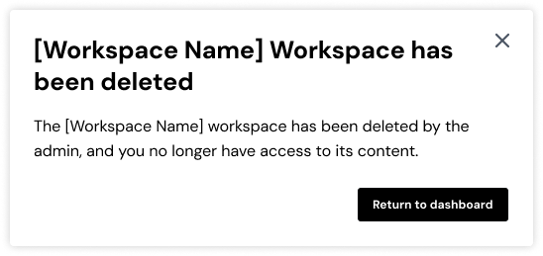

Workspace access revoked flow
When a user is removed from a workspace, the experience should be seamless and informative, making sure they understand the change and its impact on their access to projects and files, where all permissions for the user within the workspace are immediately revoked.
Immediate access revocation (UX)
Scenario 1:
When the removed user logs in on the HB web-app, where they have been removed from any workspace, they will be redirected to their personal dashboard with an error message.
- Title: You’ve been removed from [Workspace Name]
- Body: You no longer have access to the [Workspace Name] workspace, including all projects and files in it.
- Action Button: Got it

Scenario 2:
When the removed user is browsing on HB web-app other WS or personal dashboard, and they have been removed from any workspace, they will get an error message once they access next tim ethe WS they have been removed from.
- Title: You’ve been removed from [Workspace Name]
- Body: You no longer have access to the [Workspace Name] workspace, including all projects and files in it.
- Action Button: Return to dashboard
Scenario 3:
When the removed user is in the WS he has been removed from, on a blurred WS screen he shall get an error modal with a clear messaging, and will be navigated to their personal dashboard once confirmed with the modal action button.
- Title: You’ve been removed from [Workspace Name]
- Body: You no longer have access to the [Workspace Name] workspace, including all projects and files in it.
- Action Button: Return to dashboard
The removed user’s profile should reflect no association with the workspace aka WS icon should be removed from the WS sidebar.

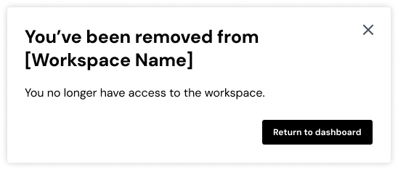

User interaction and design
- Snackbar notifications across workspaces:
Users will receive a notification (Snackbar) when they create, edit, or delete a workspace.
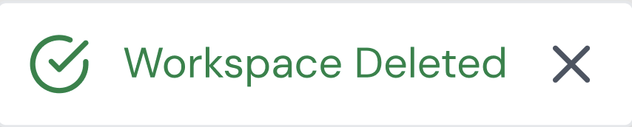
- The left navigation panel becomes visible when hovering over the navigation menu.
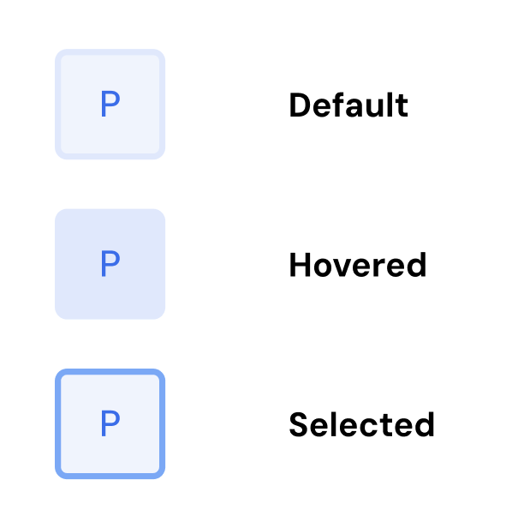

Out of Scope

Additional changes to the web app
Unassigned Sources Sidebar
- The "Unassigned Sources" panel will appear on the right side of the screen
  - Hovering over the panel opens it as an overlay.
  - Clicking the "Bookmark" icon pins the panel and shifts the project dashboard to the left.
Archived projects dashboard and logic
Deleted projects dashboard and logic

User lifecycle emails implementation

Users who are added to a workspace, whether they are existing or new users, should receive an email with the following content:

Title: "You’ve been added to the [Workspace Name] workspace on Haibrid"
Body: "[Name Surname] has created a new workspace, [Workspace Name], and added you as a Viewer/Editor. Click the button below to access the workspace and start collaborating."
Action Button: Join Workspace
Additional Text: If you weren’t expecting this ignore this email.

Note: Users who are not registered members of the platform must complete the sign-up and onboarding user flow, ultimately landing on the Workspace dashboard once onboarding is finished. Existing users should be directed to the Workspace dashboard immediately if they are logged in, or after they log in.
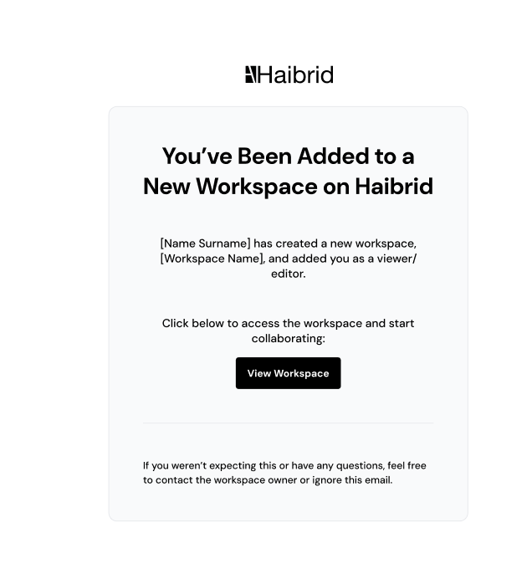
HTML visual design for the invitation email

Users who have been upgraded from a View only access to CAN EDIT access, should receive an email with the following content:

Title: "You’ve been upgraded to an Editor on Haibrid"
Body: "[Name Surname] has upgraded your role in the workspace, [Workspace Name], from a viewer to an editor."
Additional Text: “Click below to access the workspace and start collaborating with your new permissions”
Action Button: Open Workspace
Additional Text: If you weren’t expecting this ignore this email.
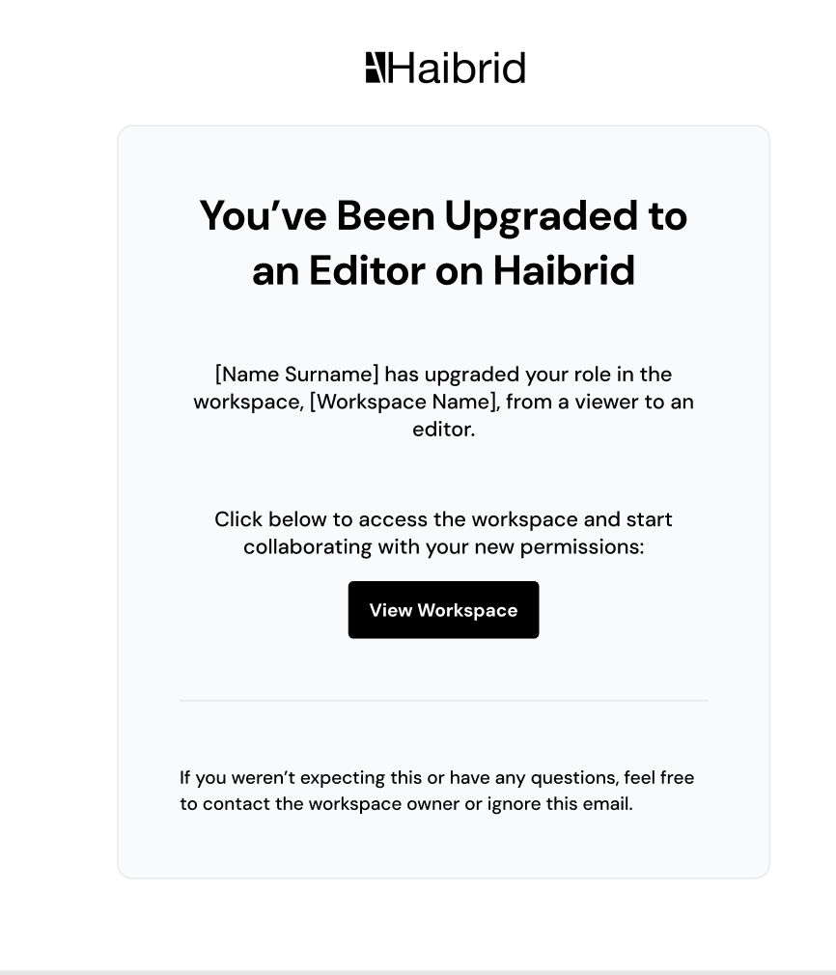
HTML visual design for the user role upgrade email

Open Questions
Please list all your questions in this section.
Some of the items to be discussed or implemented from the product team are:
- “Copy Link” workspace invitation user flow for existing users [to be implemented later]
Archived projects dashboard and logic [feature backlog]
- User navigation workflow for existing users who have been added to a Workspace but have logged into the personal dashboard or another workspace, rather than accessing it through the email notification. [Done]
- What is going to happen to the projects that are shared with users before workspace implementation?
- Extension logic before technical implementation

